ORDER OF BUSINESS
CONSTRUCTION BOARD OF ADJUSTMENT AND APPEALS (CBAA)

LOCAL CONSTRUCTION REGULATION BOARD (LCRB)

FLOOD DAMAGE PREVENTION BOARD (FDPB)

June 12, 2025- 2:00 PM

2300 North Jog Road, 1st Floor Room 1W-47

West Palm Beach, FL. 33411

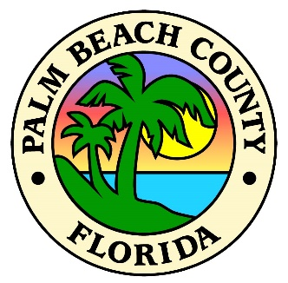

__________________________________________________________________________________________

- CALL TO ORDER / CONVENE AS CONSTRUCTION BOARD OF ADJUSTMENT & APPEALS (CBAA)
  - Roll Call

___ Rex Kirby, Division 1 Contractor, Chair ___ William Reicherter, Electrical Contractor
___ Jessica Dornblaser, Architect, Vice Chair ___ Steven Markel, HVAC Contractor
___ Timothy Wingate, Division 1 Contractor ___ Manuel Oyola, Roofing Contractor
___ Bart Rasper, Plumbing Contractor ___ Michael Riemer, Engineer

  - Approval of Minutes
    - January 9, 2025

  - Administer Oath to Witnesses

- ADDITIONS & DELETIONS

- OLD BUSINESS
  - 2024-01 - 6271 17th Drive South Trlr 718 West Palm Beach, FL 33415

- NEW BUSINESS
None

- BOARD MEMBERS COMMENTS
None

- STAFF COMMENTS
  - Next meeting scheduled is July 10, 2025.

- ADJOURNMENT

